Introduction/ Business Problem
Singapore is known as a food paradise. In 2017, the food industry in Singapore contributed S$4.3 billion or 1.1% to Singapore’s GDP and employed more than 48,000 workers. Hence, we believe that Singapore Food industry is having a great business potential.
Before entering the food industry, we would like to gather the market data and analyse the market preference about the food in Singapore. Foursquare API was being used to gather Singapore restaurant data and the market preference. While classification and liner regression are being used as machine learning mediums to provide more insights for the data.
Data
In this project, Foursquare API are utilized to gather the venues in each neighborhood of Singapore. While data processing is being apply when we remove all non-restaurant data. The “likes” data from API is pulled based on the venue ID.
After that, the Restaurant data is categories into Euro, Asian, Casual, American, and Bar. Then, we classify the likes into different ranking level.
Methodology
Exploratory data analysis
Firstly, the coordinates of the locations in Singapore are retrieved form Foursquare API. It consists of parks, spa, cafeteria and so on. After that we apply data cleaning method where we remove all irrelevant data and only keeping the restaurant data. Besides, we retrieve the “likes” data for each venues form Foursquare API.
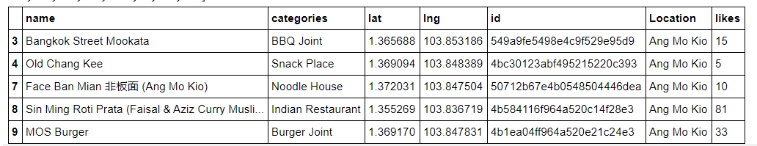
Data Processing
We categories the data into different type of cuisine such as euro, bar, Asian, casual, and American. Then we classify the “likes” into different ranking level.
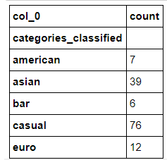
Machine Learning
Then we apply Linear Regression Modelling to study the relationship between the type of cuisine, number of “likes” and the ranking level. We train and test our model by using the data from Foursquare API. We using the ratio of 80% training and 20% testing.
Besides that, we also apply Multinomial Ordinal Logistic Regression to study the relationship between cuisine ranking level and the venue.
Results
The result for Linear Regression Model showed accuracy between 40%~70%. While Multinomial Ordinal Logistic Regression Model showed accuracy of 97.77%. Both model are using 80% random data as training set and 20% data as testing set.
Discussion
For Linear Regression Model, which showed relatively low accuracy in this study demonstrate that this model is not suitable to be used for this study. While the Multinomial Ordinal Logistic Regression Model showed high accuracy of 97% demonstrate that this model is fit to be used for this study.
Conclusion
In conclusion, Multinomial Ordinal Logistic Regression Model should be used to predict the category of restaurant that will get most likes from the city.
According to the study, the category Casual carry most likes and followed by Asian. Which means that Casual and Asian cuisine would be a great option to begin when we deciding to open new restaurant in the Town.

